**Mathematics Methods Unit 3 2019**

**Investigation 1: Roller Coaster Design**

This investigation comprises three parts.

**Part A** will take place in class to give students an introduction to the task. There are no marks allocated for this activity.

**Part B** is the Take Home Section of this assignment. Students are given time to write a report about the design of a possible roller coaster track. The marks allocated in this section will account for 50% of the task.

**Part C** is the validation section of the report and will take place in class on the date that the report is due. This mark will constitute 50% of the total investigation mark. Notes will not be allowed in this section, however calculators will be allowed.

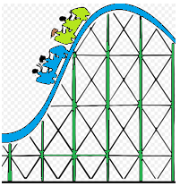**Part A**

The first task is to design an *ascent* and *drop* for the first section of roller coaster track.

You will connect two straight stretches of track,  and , with part of a parabola , where *x* and  are measured in metres.

You decide to make the slope of the *ascent* 0.8 and the slope of the *drop*  - 1.8.

For the track to be smooth there cannot be abrupt changes in direction. To ensure smooth transitions between the linear segments and the parabola -  and  need to be tangents to the parabola *f(x)* at the transition points P and Q.

Find the equations of the *three segments* of track indicated below for the given domains, showing all appropriate steps of logic:

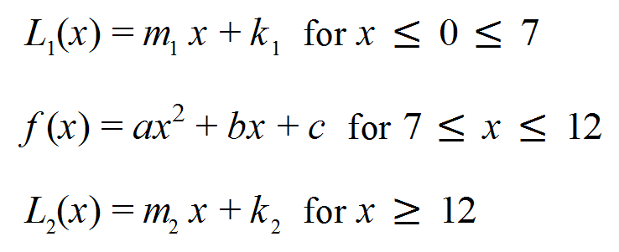

Draw these equations on your Classpad Graphic Calculator by going to Main or Graph & Table Menu and using the piecewise sections icon. Alternatively each section can be entered line by line. The first section would then look like this:

Y1 = 0.8| 0 $≤x≤7$.

Further advice on this can be found at: [http://www.classpad.com.au/cp2/index.php?me=BA2&mn=046](https://apac01.safelinks.protection.outlook.com/?url=http%3A%2F%2Fwww.classpad.com.au%2Fcp2%2Findex.php%3Fme%3DBA2%26mn%3D046&data=02%7C01%7Cdavid.martin1%40education.wa.edu.au%7Ccc6f218fc3294ee7382108d6a0868914%7Ce08016f9d1fd4cbb83b0b76eb4361627%7C0%7C0%7C636872897025316510&sdata=9rdRoTnekUA38icvaxvPOcvozd4VSQZxpClx4DUxsA4%3D&reserved=0)

and [http://www.classpad.com.au/cp2/index.php?me=BA2&mn=346](https://apac01.safelinks.protection.outlook.com/?url=http%3A%2F%2Fwww.classpad.com.au%2Fcp2%2Findex.php%3Fme%3DBA2%26mn%3D346&data=02%7C01%7Cdavid.martin1%40education.wa.edu.au%7Ccc6f218fc3294ee7382108d6a0868914%7Ce08016f9d1fd4cbb83b0b76eb4361627%7C0%7C0%7C636872897025326523&sdata=kWcqgyDVlmGfkPk7GsU4Gy0HKVru6v%2Btl6IHIQfuqQ4%3D&reserved=0)

**Part B due Friday 22 March Marks / 39**

After conducting some research on roller coaster specifications, your task is to design a roller coaster and specify the equations for your roller coaster track from the ***starting point*** (the Origin at ground level) to its ***finish point*** (exit on the right).

Within your report you must determine equations (minimum of 5) for the sections of the track to the exit point, ensuring a smooth transition between points-showing detailed working, equations, constraints, reasons for the choices etc.

You must carefully consider:

-length and height constraints

-using a range of functions in your design

-consider different techniques for generating the functions

* Using your Casio Classpad calculator to model the track you should draw a detailed, fully labelled, smooth graph showing what each section looks like, the calculations involved to define each section and the final graph on graph paper.
* Include a discussion of any assumptions, limitations and improvements in the design of your roller coaster.

The report should include the following:

* an outline of the problem and context (3 marks)
* Relevant information crucial to track design (7 marks)
* the method required to find a solution, in terms of the mathematical model or strategy used (3 marks)
* the application of the mathematical model or strategy, using appropriate representations (16 marks)
* the analysis and interpretation of results, including final graph, consideration of the reasonableness and limitations of the results, including a bibliography and appendices (10 marks)

The investigation report, excluding bibliography and appendices if used, must be a maximum of 15 A4 pages if written, or the equivalent in multimodal form. The maximum page limit is for single-sided A4 pages with minimum font size 10. Page reduction, such as 2 A4 pages reduced to fit on 1 A4 page, is not acceptable. Conclusions, interpretations and/or arguments that are required for the assessment must be presented in the report, and not in an appendix. Appendices are used only to support the report, and do not form part of the assessment decision.

You should be wary of plagiarism and acknowledge sources of information. Ultimately the report should be written in your own words. The penalty for copying will be zero marks for both reports when this is shown to have occurred.

**Part C Friday 22 March**

[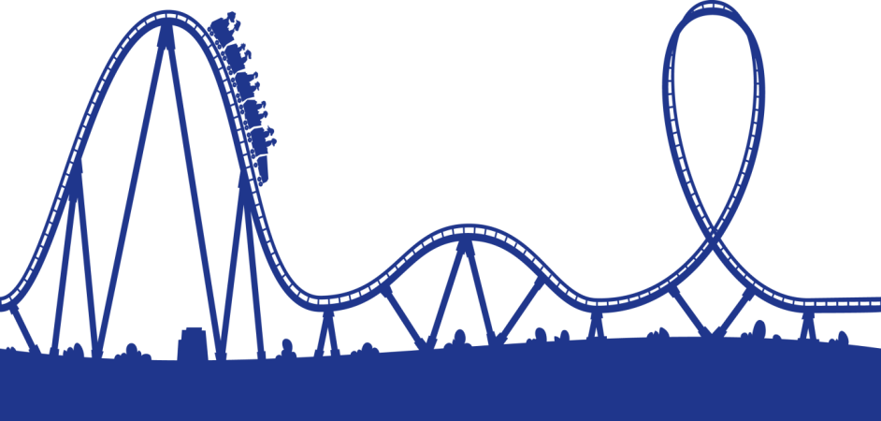](http://www.google.com.au/url?sa=i&rct=j&q=&esrc=s&source=images&cd=&cad=rja&uact=8&ved=0ahUKEwiu3K_68-XQAhWDupQKHR71DcoQjRwIBw&url=http://www.clipartkid.com/cartoon-roller-coaster-cliparts/&psig=AFQjCNGDOLcOX8vD9dBgydqxWSXPsGbdTg&ust=1481331429398684)The validation will take place in class after the reports are handed in. This validation will test your understanding of the processes involved in the activity. Calculators will be allowed in this section and marks for the validation will account for 50% of the final mark.